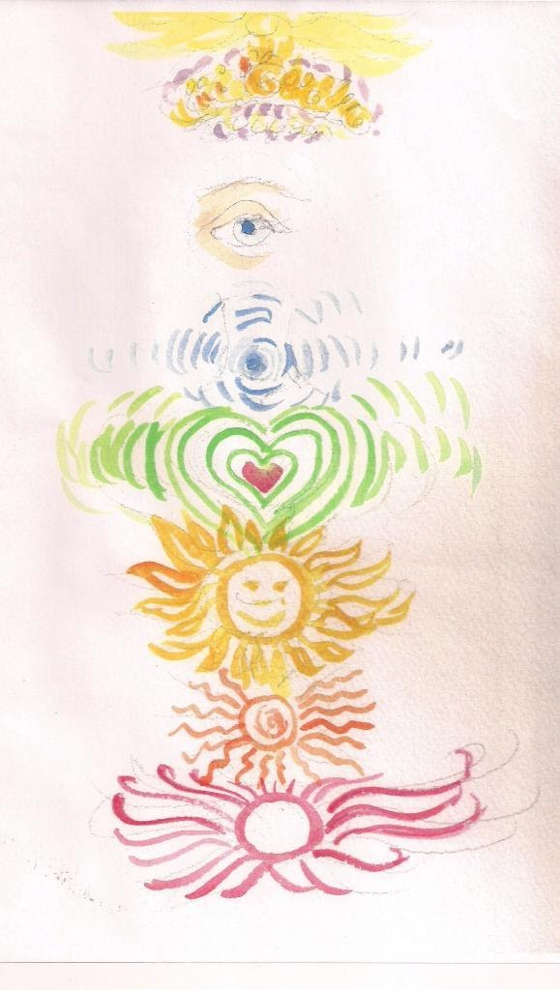

Image above c M. Mc Mahon is a diagram of the chakras.
1.Crown violet color- receiving information from divine source- Sartori, enlightenment, Kundalini
2. Third eye- color indigo Opening of intuitive development- dreams, messages, psychic awareness
3. Throat- color blue speaking ones truth, living in integrity
4. Heart chakra- Green color- empathy, compassion, emotions seat of the soul
5. Solar chakra or solar plexus- yellow Sunshine mid heaven between earth and heaven, your belly button seat of survival emotions
6. Sacral chakra- Orange, life giving family values, sexual procreative chakra
7. Root chakra- Red color base of the spine, grounded in reality, elimination of waste

